Project Plan : IE1004 – Computational Thinking

1. Title
THREESEC
2. Members of the Project
Member - 1  H.M. Nadeer | Mobile : 0783491448  E-mail : it24103622@my.sliit.lk
Member – 2  M.M.A.S.K.Mannapperuma | Mobile : 0769877753  E-mail : it24101022@my.sliit.lk
Member – 3  B.Amsawardan | Mobile : 0761912697  E-mail : it24103484@my.sliit.lk
3. Research Problem
Security of a Threewheeler
4. Overall Aim
Ensure the safety of a Threewheeler
5. Objectives of the proposed work
Objective 1: Making a circuit that suits the needs
Objective 2: Developing a App to control the operation
Objective 3: Programming the hardware components using with software
Objective 4: Approaching towards a working prototype

6. Methodology (Block Diagram, Flow chart of the process and explanations)
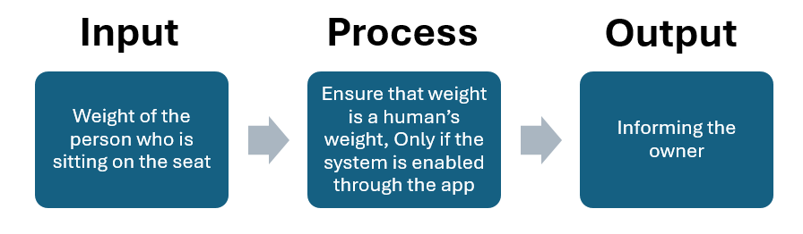
7. Expected Outcome
Ensure the safety of a threewheeler in every possible way.

